 | ICanCaRe TOBACCO USERS ORAL Screening Form 

TOBACCO USERS SCREENING
Venue: ________________________________________________________ Date: ________________

ORAL EXAMINATION | NEW CASE
 | FOLLOW UP CASE | No New Complaints  No New Lesion  New Complaints  New Lesion

ORAL EXAMINATION
Body Part, Complaint, Since When in Days, Option, Trauma?, Treated Before, Note
Neck, Painful Ulcer, 27 days, Intermittent, Yes, Yes, xxxx111
STEP 1 Patient Complaints | Can be filled by  Patient Himself  Doctor Assistant  Counsellor  Doctor
 | □No Complaints - Normal  □Complaints - Abnormal (drop down menu) | Duration:__________days  □ 1-5 days  □ 5-14 days  □ >14 days - 1 month  □ >1 month < 1 year  □ Long time  □ Occurs off and on
Abnormal complaints related to | □ Face  □ Neck  □ Oral cavity (mouth and tongue)  □ Teeth (dental)  □ Others
□ Face | □ Lump/Swelling on face  pigmentation  ulcer | □ Increasing  □ Decreasing  □ Persistent  □ Intermittent
□ Neck | □ Lump/Swelling in Neck (outside)  □ Swelling/lump in Throat (inside)  □ Stickiness in throat  □ Change in Voice  □ Sore throat/Hoarseness  □ Swallowing Difficulty/pain  □ Other | □ Increasing  □ Decreasing  □ Persistent
□ Oral cavity (mouth and tongue) | □ Restricted Mouth opening  □ Restricted Tongue Movement  □ Trauma  □ Pain  □ Painful Ulcer  □ Painless Ulcer  □ Recurrent Ulcer  □ Red patch in mouth  □ White patch in mouth  □ Nodule/Lump  □ Swelling  □ Sensitivity in mouth/teeth  □ Burning Sensation  □ Bleeding  □ Decreased Salivation  □ Increased Salivation  □ Foul Smell (Halitosis)  □ Swallowing Difficulty/pain during  □ Others | Onset -When did the lesion appear?  Duration: __________days  □ Is Intermittent  □ Is Recurrent  Choose one:  o Increasing  o Decreasing  o Persistent  □ Trauma - Did you experience any trauma in the area?  □ Did you undergo medical treatment
□ Teeth (dental) | □ Painful teeth  □ Loosening of teeth  □ Lost teeth  □ Teeth or gum problem  □ Denture problem | Same options as above
□ Others | □ Earache  Specify ………………… | Same options as above
 | □ Others, please specify

STEP 2 Physical Examination | Done by Doctor  Doctor Assistant
 | Location | Side |  | Abnormality
 | Face  Neck  Mouth  Dental  Throat |  | □ Normal  □ Abnormal
Face | □ Forehead - Left  □ Forehead - Right  □ Eye (L, R)  □ Nose (L, R)  □ Chin  □ Cheek (L, R)  □ Parotid (L, r)  □ Ear (L, R) |  |  | □ Asymmetry  □ Swelling/Nodule  □ Lymph Nodes  □ Ulcer  □ Decreased movement
Neck | □ Neck - Left  □ Neck - Right  □ Neck - Central  □ SUBMANDIBULAR - Left  □ SUBMANDIBULAR - Right  □ THYROID - Left Lobe  □ THYROID - Right Lobe  □ THYROID - Central  □ Parathyroid  □ Back of Neck - Left  □ Back of Neck - Right  □ Any other |  |  | □ Pain  □ Asymmetry  □ Swelling/Nodule  □ Lymph Nodes  □ Ulcer
Mouth

 | Mouth Opening |  |  | Mouth Opening:  Fingers - One □ Two □ Three□ Four□  Measured: …… mm  Measured with: [TrisCare, Caliper]
 | Tongue |  |  | Tongue Movement  □ Normal tongue  □ Painful tongue  □ Tongue Deviation to left  □ Tongue Deviation to Right  □ Restricted Protrusion of tongue  Tongue Protrusion measured by scale  In …………………. mm
 | Oral Hygiene |  |  | □ Good oral hygiene  □ Moderate oral hygiene  □ Poor oral hygiene
 | Prosthesis |  |  | Yes/No
 | Teeth |  |  | Child Table:  Teeth# (comma separated numbers), Issues (multi-select Issue List)  Issue List  □Loose teeth  □Painful teeth  □Lost teeth  □Caries teeth  □Stained teeth  □Calculus around teeth  □Missing teeth  □Broken teeth  □Abrasion teeth  □Irregular alignment of teeths  □Sharp teeth  □Attrition in teeth  □Root stump teeth  □Tender teeth
 | Definition  □ Single  □ multiple |  |  | □ Localized (focal, found in one area only)  □ Generalized (diffuse, found in most of the tissues in one area)
 | Lesion Location  □ Lower lip (L, R)  □ Upper lip (L, R)  □ Anterior Arch (L, R)  □ Upper anterior GB sulcus (L, R)  □ Lower anterior GB sulcus (L, R)  □ Angle of Mouth (L, R)  □ Upper Alveolus and Gingivo-Buccal Sulcus Maxillary Gingiva (L, R)  □ Lower Alveolus and Gingivo-Buccal Sulcus Mandibular Gingiva (L, R)  □ Ventral Tongue (L, R, Midline)  □ RMT (L, R)  □ Dorsum Tongue and Anterior floor of mouth  □ Lateral Tongue and FOM (L, R)  □ Buccal mucosa (L, R)  □ Hard palate (L, R, Midline)  □ Soft palate (L, R, Midline)  □ Oropharynx (L, R, Midline)  □ Base of Tongue (L, R, Midline)  □ Tonsil (L, R) |  |  | Child Table:  Location, Color, Shape, Description, Palpation, Texture, Note (text)  Example of Note: Use fixed anatomical landmarks (e.g., “5 mm from tip of tongue, 3 mm from midline”)
 | Distribution |  | Note that a well-defined margin can have regular or irregular borders. | □ Well-defined (circumscribed)  □ Poorly-defined (vague)  □ Regular  □ Irregular borders
 | Size | Length × Width × Height (in mm) | Measure with probe; note greatest dimensions | ………….. mm
 | 4. Color of lesion |  |  | □ Uniform lesion in mouth oral cavity  □ Variegated color lesion in mouth oral cavity  □ White lesion in mouth oral cavity  □ Red lesion in mouth oral cavity  □ Black lesion in mouth oral cavity  □ Brown lesion in mouth oral cavity  □ Mixed type lesion in mouth cavity
 | 4. Shape of Lesion  □ Round  □ Oval  □ Irregular  □ Rectangular |  |  | Lesion Description  OPEN MOUTH EXAMINATION Visual Inspection (Select box)  □ Foul Smell Halitosis  □ Cracked lip/angle of Mouth  □ Macule—flat lesion in mouth  □ Vesicle—elevated lesion in mouth/oral cavity  □ Pustule—purulent lesion (filled with pus) lesion in mouth/oral cavity  □ Papule—lesion less than 5 mm in diameter, raised with no fluid lesion in mouth/oral cavity  □ Nodule—lesion less than 2 cm in diameter, raised with no fluid lesion in mouth/oral cavity  □ Plaque—broad, slightly raised lesion in mouth/oral cavity  □ Sessile-based—broad attachment lesion in mouth/oral cavity  □ Pedunculated—stalk-like attachment lesion in mouth/oral cavity  □ White Patch (leukoplakia) lesion in mouth/oral cavity  □ SMOOTH white (Homogenous) lesion in mouth/oral cavity  □ Verrucous greyish white lesion in mouth/oral cavity  □ Irregular white lesion in mouth/oral cavity  □ Lacy like lesion in mouth/oral cavity  □Verrucous  □ Red Patch (Erythroplakia) lesion in mouth/oral cavity  □ Smooth REd lesion in mouth/oral cavity  □ Erosive red lesion in mouth/oral cavity  □ Superficial Ulcer lesion in mouth/oral cavity  □ Deep Ulcer lesion in mouth/oral cavity  □ Deep ulcer with Smooth margins lesion in mouth/oral cavity  □ Deep ulcer with Irregular margins lesion in mouth/oral cavity  □ Fungal lesion (white lesion scrapable) lesion in mouth/oral cavity  □ Bleeding lesion in mouth/oral cavity  □ Marbelled lesion in mouth/oral cavity  □ Fibrous bands lesion in mouth/oral cavity  □ Hypertrophic Mucosa lesion in mouth/oral cavity
 | 6. Consistency |  | Palpate gently using gloved finger | PALPATION (Gloved fingers)  □ Tender -painful on touch lesion in mouth/oral cavity  □ Soft lesion in mouth/oral cavity  □ Firm to feel lesion in mouth/oral cavity  □ Hard to feel lesion in mouth/oral cavity  □ Fluctuant lesion in mouth/oral cavity  (fluid-filled lesion that moves fluid from one area to another when the lesion is pressed)  □ Bleeds on Touch lesion in mouth/oral cavity  □ Blanching of mucosa (Marble) SMF lesion in mouth/oral cavity  □ Scrapable lesion white or red lesion in mouth/oral cavity  □ Non -Scrapable lesion lesion in mouth/oral cavity  □ Smooth border lesion in mouth/oral cavity  □ Irregular border lesion in mouth/oral cavity  □ Induration present lesion in mouth/oral cavity  □ Induration absent lesion in mouth/oral cavity
 | 7. Texture |  | Use tactile and visual assessment | □ Smooth  □Rough—papillary (finger-like projections)  □ Corrugated (rippled)  □ Fissured (deep crevices)  □ Crusted (covered with scab)
Dental | Dental number give reference | □Right upper  □Right lower  □Central upper  □Central lower  □Left upper  □Left Lower | Normal  Abnormal | Dental Assessment:  □Loose teeth  □Painful teeth  □Lost teeth  □Caries teeth  □Stained teeth  □Calculus around teeth  □Missing teeth  □Broken teeth  □Abrasion teeth  □Irregular alignment of teeths  □Sharp teeth  □Attrition in teeth  □Root stump teeth  □Tender teeth

STEP 3 - Representation MARKING on the Diagram
FACE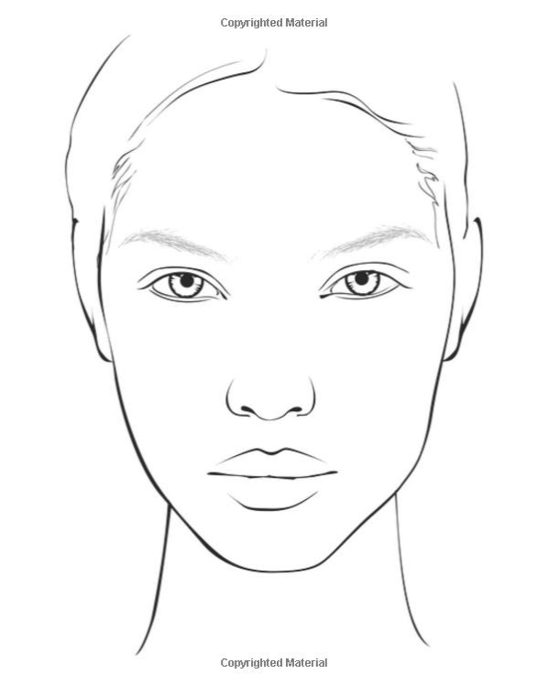 | 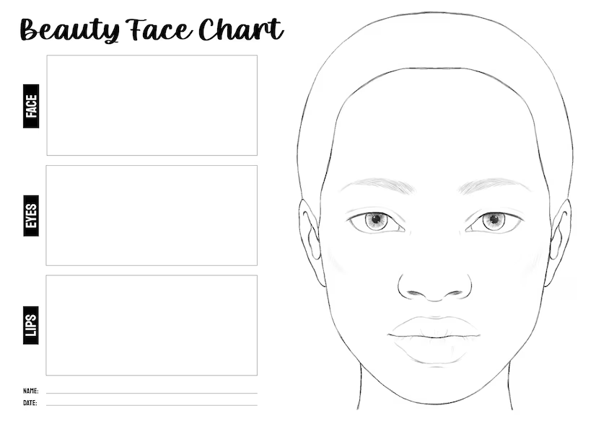
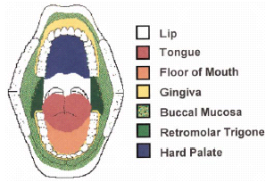 | 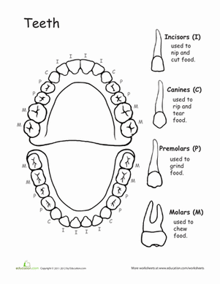
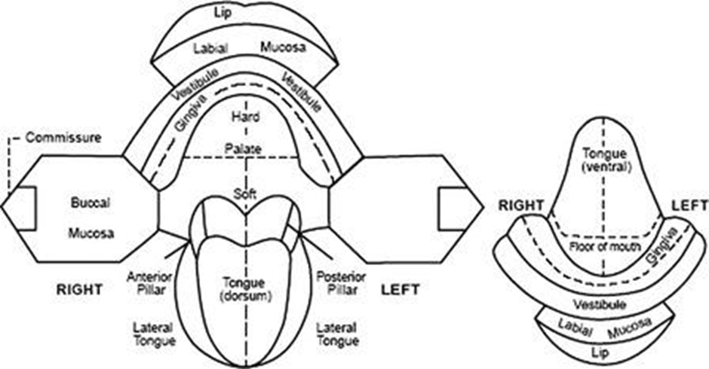
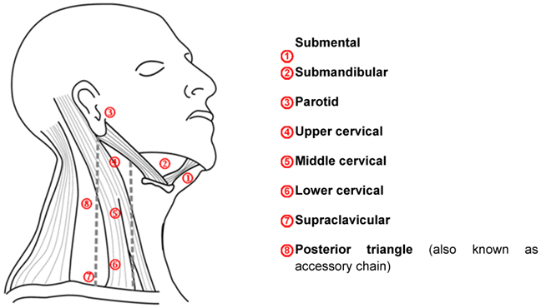 | 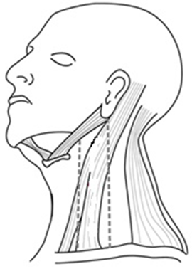
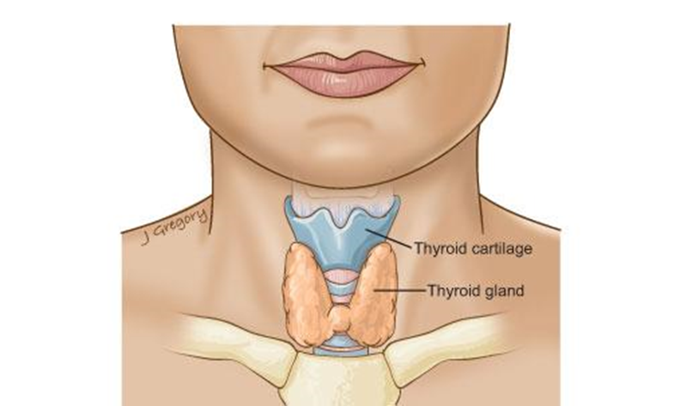
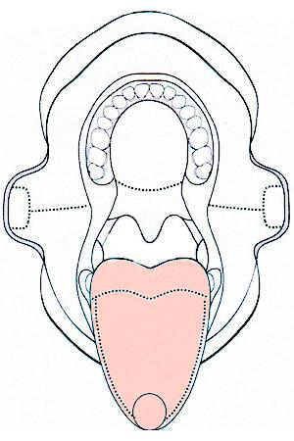 | 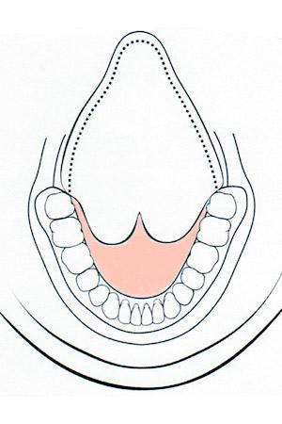

STEP 4 - PICTURES to be taken - patient can take and upload
Taken by Doctors assistant
Taken by Doctor
STEP
1 | Face and Neck
2 | Open mouth with finger or measurement scale or Triscare
3 | Central arch with both lips
4 | Right Cheek with Alveolus
5 | Left Cheek with Alveolus
6 | Tongue Protruded
7 | Tongue pulled up with Floor of Mouth
8 | Hard and Soft palate
9 | Abnormal area focused
10 | Special tests

STEP 5 SPECIAL TESTS: (Skip for now)
 | Parameters | Findings
Toluidine Blue test |  | □ Normal □ Low Suspicious □ High Suspicious
Blue light |  | □ Normal □ Low Suspicious □ High Suspicious
Autofluorescence Test |  | □ Normal □ Low Suspicious □ High Suspicious
Spectroscopy Test |  | □ Normal □ Low Suspicious □ High Suspicious

STEP 6 - Interpretation/Advice (Provisional Diagnosis)
- Normal, routine screening after 1 year, continue self-oral examination
- Normal with risk factors, close screening every six months
- Potentially Malignant lesions, precancerous lesions, need further management.
- High risk, need to see the nearest center for further evaluation
- Suspicious for cancer, need to see the nearest center for further evaluation
- Frank malignancy, requires immediate treatment visit specialized cancer center
- Insufficient data for any comments, repeat examination
- Inflammation or infection or nutritional factors to be ruled out or treated and then repeat examination
- High Risk factors needs consultation for Tobacco de addiction
- Recommend advice regarding Alcohol Use
□ Recommend Dental Care

Prescription/ADVICE at the Screening Camps or first visit when patient is not ready to do anything further
ASSESSMENT: NORMAL□ Risk for PML/Cancer Low Risk □ High risk □

ADVICE: □Recommend tobacco cessation□
□Educate about alcohol use□
□Recommend Dental Care□
□Referred for Other Specialist Review□
□Referred for higher Centre for Oral Evaluation□

PRESCRIPTION - ADVISE AND TREATMENT - ORAL MEDICATIONS
DATE
NAME OF THE DOCTOR/HOSPITAL
□ Mouth opening exercise - TRISCaRe Regular use
□ Tab Folic Acid (5 mg) 1 tab thrice/once daily for 30 days
□ Tab Vit C + Zinc tab Cbinan once daily for 30 days
□ Mutlivitamins, Multiminerals - Tab Vitabliz 1 tab once daily
□ Oral Probiotics – Sporalac DG chewable tablets 1 tab twice daily for 3 months
□ Oral Gargles – regular use - Turmwash/BiQOL
□ Antioxidants - Tab Clik/Lycoedge 1 cap once a day
□ Antifungal oral application - Clotrace lozenges 1 tab thrice daily
□ Antifungal tablets - tab Forcan 100/150 mg 1 tab once a day for 14 days
□ Tab Curcunan/Turmnova tab 1 tab twice daily for 3 months
□ Local Anti Inflammatory Analgesic - Turminace Gel/ Metrogyl DG LA Gel
□ Artificial Saliva - Spray/Gargles - Oraxero Spray
□ Toothpaste -
Treatment management of oral lesions -
Procedure to be done ORAL
□ BIOPSY
□ Excision
□ PBM
□ PDT
□ Vapourisation - LASER, Electrocautery,
□ Oral Prophylaxis
□ Dental Rehabilitation

Examiner Signature …………………..

LAB TEST at the Screening Camps or first visit

LABORATORY TESTS
 | DATE
PANEL | LAB NAME
 |  | PACKAGE - MAX Full- Body Health Check |  | ICanCare Smoker Panel 1 | ICanCare Smoker Panel 2
 |  | Rs. 2500 |  | Rs 6000 | Rs 5000
CBC |  | Y
 | Haemoglobin
DIABETES PANEL |  | Y
 | RBS | Y
 | Glycosylated Haemoglobin | Y
LIVER FUNCTION TEST |  | Y
 | Bilirubin Total
 | Bilirubin Direct
 | Bilirubin Indirect
 | SGOT
 | SGPT
 | Alkaline Phosphatase
 | Albumin
 | Globulin
 | A:G ratio
 | Gamma Glutamyl Transferase
RENAL FUNCTION TEST |  | Y
 | Blood Urea
 | Sr. Creatinine
 | Uric Acid
 | Calcium | Y |  |  | Y
 | Phosphorus
ELECTROLYTES
 | Sodium
 | Potassium
 | Sr. Magnesium |  |  | Y | Y
 | Sr. Zinc |  |  | Y | Y
LIPID PROFILE |  | Y
 | Total Cholesterol
 | Triglycerides | Y
 | HDL Cholesterol | Y
 | LDL Cholesterol | Y
ANAEMIA PROFILE
 | IRON | Y
 | TIBC (total Iron Binding Capacity
VITAMIN
 | Vit B12 | Y |  | Y | Y
 | Vit D3 | Y |  | Y | Y
 | Sr. Folic Acid |  |  | Y | Y
THYROID PROFILE
 | T3 Tri-iodothyronine
 | T4Total Thyroxine
 | TSH Thyroid Stimulating Hormone | Y
 | C-Reactive Protein
SMOKERS LUNG TEST | Alpha-1 Antitrypsin (AAT) |  |  | Y
 | URINE COTININE |  |  | Y | Y
URINE ROUTINE |  | Y
 | Urine glucose
 | Urine Protein
 | Urine Pus Cells
 | Urine RBC
CANCER PROFILE | Sr PSA
 | Sr CEA
 | Sr. CA 125

STEP 7 MANAGEMENT Intervention

OPD procedure - Scarp cytology, Saliva biomarkers/special Tests
Lab Tests - Biochemistry and Hematology
Radiology Tests
Prescription | 1st Prescription as above
Follow up with reports 1st
Management plan | □ Conservative Medicines only  □Tobacco Cessation  □Dental Care  □ Local Oral Management  □ Referred to higher Center  Follow up on regular interval
Advice for procedure in-Centre | Procedure to be done ORAL  □ BIOPSY  □ Excision  □ PBM  □ PDT  □ Vapourisation - LASER, Electrocautery,  □ Dental Prophylaxis  □ Dental Rehabilitation
Procedure Done | □ In Centre  □ Outside  □ Cancer or Oral Specialized centre Referral centre
Follow up of patient at regular interval
MOUTH OPENING - Record
TOBACCO HISTORY SMOKING or CHEWING | □ Continues  □ STOPPED
ALCOHOL HISTORY | □ Continues  □ STOPPED
General Parameters  BP  RBS  CO  PEEK  Weight | □ Stable  □ Better  □ Needs Specialist Care
Review of Reports - LAB Reports -  Note on the APP  Parameters not in normal limit highlighted for management | □ Stable  □ Better  □ Needs Specialist Care
Response to treatment conservative/PBM/PDT  PICTURES TO BE TAKEN FOR RECORD AND COMPARISON | □ STABLE  □ PROGRESSIVE  □ REGRESSION  □ Partial response  □ Complete response  □ NEW LESION - to be recoded
Follow up treatment post Surgical intervention/  LAser  Excision | Healing  Healed
Advise | □Recommend tobacco cessation  □Educate about alcohol use  □Recommend Dental Care  □Referred for Other Specialist Review  □Referred for higher Centre for Oral Evaluation
Prescription | Supplements  Vit B12, D3, E, Vit C,
Follow up date

FOLLOW UP - 1M, 2M 3 monthly

Follow up

Follow up of patient at regular interval
MOUTH OPENING - Record
TOBACCO HISTORY SMOKING or CHEWING | □ Continues  □ STOPPED
ALCOHOL HISTORY | □ Continues  □ STOPPED
General Parameters  BP  RBS  CO  PEEK  Weight | □ Stable  □ Better  □ Needs Specialist Care
Review of Reports - LAB Reports -  Note on the APP  Parameters not in normal limit highlighted for management | □ Stable  □ Better  □ Needs Specialist Care
Response to treatment conservative/PBM/PDT  PICTURES TO BE TAKEN FOR RECORD AND COMPARISON | □ STABLE  □ PROGRESSIVE  □ REGRESSION  □ Partial response  □ Complete response  □ NEW LESION - to be recorded
Follow up treatment, post Surgical intervention/  LASER  Excision | □ Healing  □ Healed
NEW LESION
Prescription | Supplements  Vit B12, D3, E, Vit C,
Advise | ORAL  □ BIOPSY  □ Excision  □ PBM  □ PDT  □ Vapourisation - LASER, Electrocautery,  □ Dental Prophylaxis  □ Dental Rehabilitation  □ Follow Up
LAB TEST
Radiology Tests
Follow up date

